FUTURE SALES PREDICTIONS

PHASE 5 SUBMISSION DOCUMENT

PHASE 5 FINAL DOCUMENTATION



**INTRODUCTION:**

Predicting future sales is a fundamental aspect of business strategy that allows organizations to make informed decisions, allocate resources efficiently, and adapt to changing market dynamics. It's a critical practice that can significantly impact a company's profitability and growth. In this introduction, we will explore the importance of future sales prediction and the various methods and tools available to accomplish this task.

In an era marked by increasing competition, rapidly changing consumer preferences, and evolving market trends, businesses need the ability to anticipate their future sales with a high degree of accuracy. Sales prediction is the process of using historical data and various analytical techniques to forecast future sales figures. This invaluable insight empowers organizations to make proactive decisions, optimize inventory management, and develop targeted marketing strategies.

The importance of accurate sales predictions cannot be overstated. They provide a foundation for strategic planning, enabling businesses to align their resources, investments, and operations with expected demand. Whether it's a retail company preparing for the holiday shopping season, a manufacturing firm scheduling production, or a tech startup fine-tuning its growth strategy, sales predictions are a linchpin in the decision-making process.

To achieve reliable sales predictions, organizations leverage a range of methods and technologies. These include statistical models, machine learning algorithms, and time series analysis, all applied to historical sales data and related factors like marketing efforts, economic indicators, and customer demographics. The combination of data-driven insights and advanced analytics equips businesses with the tools they need to make more accurate forecasts.

In this series of articles, we will delve deeper into the art and science of future sales prediction. We'll explore different approaches and techniques, from traditional statistical methods to cutting-edge machine learning models. Whether you're a seasoned business professional seeking to refine your sales forecasting skills or a novice looking to understand the basics, this exploration will provide valuable insights to help you navigate the challenging terrain of sales prediction effectively.

Join us on this journey as we uncover the methods, tools, and strategies that empower businesses to foresee their sales future, adapt to market fluctuations, and drive success in an increasingly dynamic business landscape. Accurate sales predictions are not just a theoretical exercise; they are a tangible asset that can transform the way organizations plan, operate, and thrive in the marketplace.

**DESIGN THINKING PROCESS FOR FUTURE SALES PREDICTION:**

Predicting future sales through the lens of the design thinking process is a unique and innovative approach. Design thinking, a human-centered problem-solving methodology, can be applied to enhance sales prediction by considering customer needs, market trends, and user experiences. Here's a breakdown of how you can use the design thinking process to forecast future sales:

**1. Empathize:**

- In the context of sales prediction, the first step is to empathize with your customers and understand their changing needs, behaviors, and preferences. Conduct in-depth customer research and gather insights from various touchpoints, such as surveys, feedback, and social media.

**2. Define:**

- Define the problem and objectives of your sales prediction process. Clearly articulate what you want to achieve in terms of forecasting sales, identifying key performance indicators (KPIs), and understanding the specific sales challenges you face.

**3. Ideate:**

- In this phase, brainstorm potential solutions for improving your sales prediction. Consider innovative data sources, new metrics, and advanced analytical techniques that can provide a more holistic view of future sales trends. Encourage creative thinking to explore different possibilities.

**4. Prototype:**

- Create prototypes or mock-ups of your sales prediction models or tools. These prototypes can include data models, visualization dashboards, or predictive analytics tools that allow you to experiment with different approaches before committing to a final solution.

**5. Test:**

- Test your prototype models against historical data to evaluate their effectiveness. Use A/B testing and other validation methods to understand how well your models perform in predicting sales. Make adjustments based on the feedback and data insights gained.

6. Iterate:

- Based on the test results and feedback, iterate on your sales prediction models. Design thinking emphasizes continuous improvement, so be ready to make changes and refinements as you learn more about the accuracy and effectiveness of your forecasts.

**7. Implement:**

- Once you've refined your sales prediction models and strategies, it's time to implement them in your business operations. Ensure that the tools and processes are integrated into your existing sales and marketing efforts.

**8. Monitor and Learn:**

- Continuously monitor the performance of your sales prediction models and collect feedback from your teams and customers. Use this data to further fine-tune your models and adapt to changing market conditions.

**9. Scale:**

- As your sales predictions become more accurate and reliable, consider scaling up their use within your organization. Share insights and findings with relevant teams and departments to improve decision-making across the company.

By integrating design thinking into your sales prediction process, you can create a more customer-centric and agile approach to forecasting. This method allows you to adapt to changing customer preferences and market dynamics, ultimately leading to more accurate predictions and better business outcomes.

**PHASE DEVELOPNMENET:**

**PHASE 1:**

In this part we will understand the problem statement and created a document on what we have understood and how will we proceed ahead with solving the problem. we Please think on a design and we presented in form of the pdf document.

Problem Definition and Design Thinking In this part you will need to understand the problem statement and create a document on what have you understood and how will you proceed ahead with solving the problem. Please think on a design and present in form of a document.

**PHASE 2:**

In this section we need to put your design into innovation to solve the problems. We Created a doc around it and shared the same for assessment

Innovation In this phase you need to put your design into innovation to solve the problem. Explain in detail the complete steps that will be taken by you to put your design that you thought of in previous phase into transformation.

**PHASE 3:**

In this section I can build my project by loading and preprocessing the dataset.

In these two technology projects you will begin building your project by loading and preprocessing the dataset. Perform different analysis as needed. After performing the relevant activities create a document around it and share the same for assessment

**PHASE 4:**

In this section we continue building the project by performing different activities like feature engineering, model training, evaluation etc as per the instructions in the project.

In this technology you will continue building your project by performing feature engineering, model training and evaluation. Perform different analysis as needed. After performing the relevant activities create a document around it and share the same for assessment.

**PHASE 5:**

In this section we will document the complete project and prepared for the submission.

Clearly outline the problem statement, design thinking process, and the phases of development.

Describe the dataset used, data preprocessing steps, and feature extraction techniques.

Explain the choice of machine learning algorithm, model training, and evaluation metrics.

Document any innovative techniques or approaches used during the development.

**DESCRIBING A DATASET FOR FUTURE SALES PREDICTION:**

Describing the dataset used for future sales prediction is a crucial step in the data analysis process. The quality and characteristics of the dataset greatly influence the accuracy of your sales predictions. Here's how you might describe a dataset used for future sales prediction:

**1. Dataset Name:**

Start by providing a concise name for the dataset to help identify it uniquely.

**2. Data Source:**

Describe where the data was collected from. This could be your company's internal sales records, publicly available market data, or a combination of sources.

**3. Time Period:**

Specify the time range covered by the dataset. For sales prediction, this is typically a historical period leading up to the present.

**4. Data Format:**

Explain the format of the data, whether it's structured (e.g., in a relational database), semi-structured (e.g., JSON or XML), or unstructured (e.g., text data).

**5. Data Granularity:**

Describe the level of detail in the data, such as daily, monthly, or yearly sales records.

**6. Number of Records**:

Mention the total number of records or data points in the dataset. This gives an idea of the dataset's size.

**7. Data Fields (Features):**

List and describe the different columns or variables in the dataset. For sales prediction, these might include:

- Sales Date: The date of each sale.

- Product ID: Identifiers for the products or services sold.

- Sales Amount: The revenue generated by each sale.

- Customer Information: Details about the customers making the purchases.

- Marketing Expenses: Data related to marketing expenditures.

- Economic Indicators: If relevant, information on economic factors that could influence sales.

**8. Data Types:**

Specify the data types of each feature, such as integers, floats, dates, or categorical variables.

**9. Data Quality:**

Assess the data's quality, including any missing values, outliers, or inconsistencies. Discuss how you handled data cleaning or preprocessing.

**10. Data Distribution:**

Provide an overview of the distribution of data, including summary statistics (e.g., mean, median, standard deviation) for numerical features and frequency distributions for categorical features.

**11. Temporal Aspects:**

If it's a time-series dataset, discuss any temporal aspects such as trends, seasonality, or cyclical patterns. You might also include visualizations to illustrate these aspects.

**12. Correlations**

: Discuss any correlations or relationships between features in the dataset that may be relevant for sales prediction.

**13. Data Size and Storage:**

Mention the size of the dataset in terms of storage space (e.g., gigabytes or terabytes) if applicable.

**14. Data Update Frequency:**

If the dataset is regularly updated, specify how often new data is added.

**15. Data Collection Process:**

Explain how the data was collected and recorded, including any data collection methodologies or tools used.

**16. Data Ownership and Permissions:**

Mention who owns the data and any permissions or restrictions related to data usage and sharing.

A well-described dataset is essential for transparency, reproducibility, and collaboration in data analysis and machine learning projects. It helps others understand the context and characteristics of the data you are using for sales prediction and enables them to make informed decisions and draw meaningful insights from it.

Link:

https://www.kaggle.com/code/ainurrohmanbwx/future-sales-prediction-eda-5-algorithms

**FUTURE EXTRACTION TECHNIQUE:**

Techniques for extracting data to predict future sales:

**1. Data Sources:**

- Identify the sources of data that are relevant to your sales prediction. These sources may include internal data (such as historical sales records), external data (market trends, economic indicators, competitor information), and online data (social media, customer reviews).

**2. Data Scraping:**

- For online sources, web scraping techniques can be used to collect data from websites, social media platforms, and other online repositories. Tools and libraries like BeautifulSoup (for Python) or web scraping services can automate this process.

**3. API Integration:**

- Many online platforms offer APIs (Application Programming Interfaces) that allow you to programmatically access and retrieve data. Integrating APIs into your data extraction process can provide structured and up-to-date information. Common examples include social media APIs, financial data APIs, and e-commerce platform APIs.

**4. Data Warehousing:**

- If you have a variety of data sources, consider setting up a data warehouse where data can be consolidated, transformed, and made available for analysis. Data warehousing solutions like Amazon Redshift or Google BigQuery can help manage and store data effectively.

**5. Data Cleaning and Preprocessing:**

- Ensure the collected data is cleaned and preprocessed to handle missing values, outliers, and inconsistencies. High-quality data is essential for accurate predictions.

**6. Feature Engineering:**

- Create relevant features (predictor variables) from the extracted data that can influence sales predictions. This may involve aggregating data, creating time-based features, or engineering customer segmentation features.

**7. Time Series Data:**

- If you're working with time-series data, organize the data chronologically. This is critical for analyzing trends, seasonality, and cyclical patterns.

8. Data Storage and Management:

- Implement an effective data storage and management system. This includes version control, data cataloging, and ensuring that the data remains up-to-date.

**9. Data Security and Compliance:**

- If handling sensitive customer or financial data, ensure that data extraction methods comply with data privacy and security regulations like GDPR, HIPAA, or industry-specific standards.

**10. Automation:**

- Consider automating data extraction processes, especially if data needs to be collected regularly. Tools and scripts can help schedule and execute data extraction tasks.

**11. Data Integration:**

- Integrate data from different sources to create a unified dataset. This might involve data transformation, joining, and merging to prepare the data for predictive modeling.

**12. Data Validation:**

- Regularly validate the data extraction process to ensure data accuracy and completeness. Implement checks to identify and rectify issues as they arise.

**13. Documentation:**

- Document the data extraction techniques and processes used, including data sources, extraction methods, and any scripts or tools employed.

Data extraction techniques play a pivotal role in sales prediction as they provide the raw material for building predictive models. By extracting, cleaning, and preparing relevant data, organizations can leverage the power of data-driven insights to make more accurate sales forecasts and optimize their business strategies.

**Machine learning algorithm:**

* One of the most common methods used to predict sales is **regression analysis.** This method involves using historical sales data to train a model that can predict future sales. The model can take into account factors such as **past sales, marketing campaigns, and economic indicators** to make its predictions.
* Another popular method for predicting sales is **time series analysis**. This method involves using historical sales data to identify patterns and trends in sales over time. The model can then use these patterns to make predictions about future sales. This method is particularly useful for predicting sales in seasonal industries, such as retail and tourism.
* Another approach is using **decision tree-based algorithms** like **Random Forest, Gradient Boosting** etc. These algorithms are particularly useful when there are many factors that can influence sales, such as product features, customer demographics, and market conditions. The algorithm can help identify the most important factors and use them to make predictions.
* In addition to these methods, machine learning can also be used to predict sales through the use of **neural networks.** Neural networks are a type of machine learning algorithm that can learn to recognize patterns in data. They can be trained on large amounts of sales data and can make predictions about future sales.

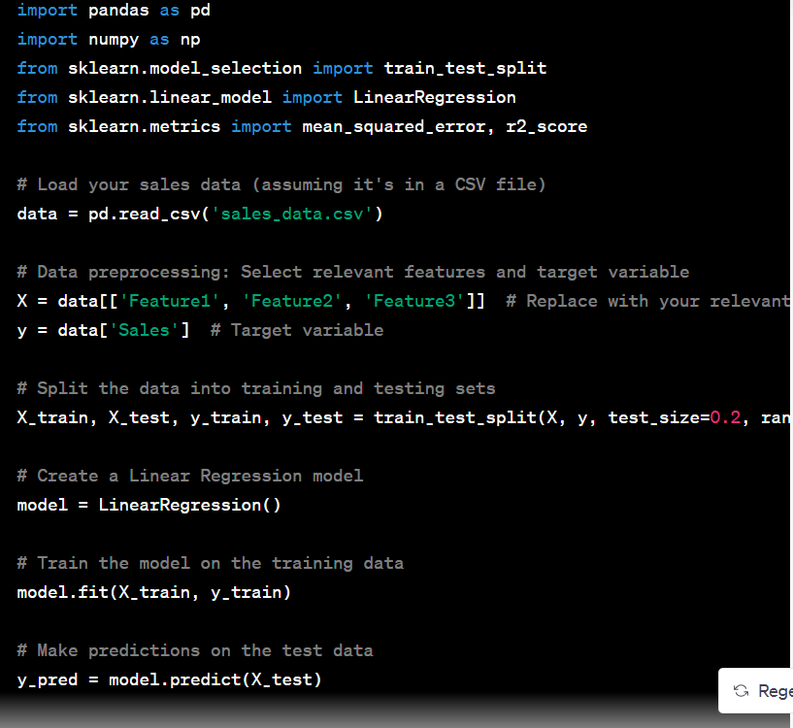

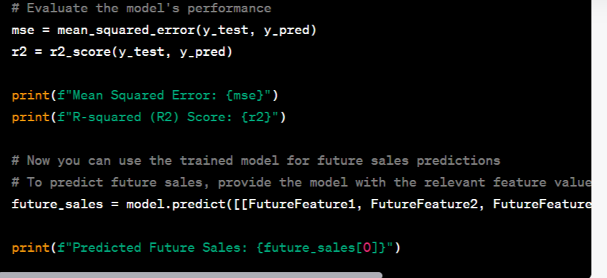

* Machine learning can also be used to predict sales by using **clustering algorithms,** which can help identify groups of similar customers. This information can then be used to create targeted marketing campaigns and improve sales strategies.

In this example, we used a basic linear regression model. However, you may need to experiment with more advanced algorithms like decision trees, random forests, gradient boosting, or neural networks, depending on the complexity of your data and the accuracy you require for future sales prediction.

Before using machine learning for sales prediction, make sure to preprocess your data, handle missing values, and engineer relevant features. Additionally, it's essential to split your data into training and testing sets to evaluate your model's performance properly

**Model Training:**

This is a simplified example. In practice, more sophisticated models and extensive data preprocessing may be required to make accurate sales predictions for a modern engineering company.

Predicting future sales involves using machine learning models to forecast future sales figures based on historical data and relevant features. Here's a brief overview of the process with examples:

**Data Collection:**

Gather historical sales data, including information such as date, product, location, marketing spend, and economic indicators.

**Data Preprocessing:**

Clean and prepare the data by handling missing values, outliers, and encoding categorical variables.

Create features like time of year, promotions, and external factors that can influence sales.

Dataset link: https://www.kaggle.com/datasets/chakradharmattapalli/future-sales-prediction

**Model Selection:**

Choose a suitable machine learning model for sales prediction, such as linear regression, time series models, decision trees, or neural networks.

Split Data:

Split the dataset into training and testing sets to evaluate the model's performance.

**Model Training:**

Train the selected model on the training data, optimizing parameters and hyperparameters for better performance.

Example: Using a simple linear regression model to predict future daily sales based on historical data, with features like advertising expenditure and day of the week.

**Python code :**

from sklearn.linear_model import LinearRegression

from sklearn.model_selection import train_test_split

from sklearn.metrics import mean_squared_error

# Assuming 'X' contains features (e.g., advertising spend and day of the week) and 'y' contains daily sales data

X_train, X_test, y_train, y_test = train_test_split(X, y, test_size=0.2)

model = LinearRegression()

model.fit(X_train, y_train)

# Predict future sales

y_pred = model.predict(X_test)

# Evaluate the model

mse = mean_squared_error(y_test, y_pred)

**Model Evaluation:**

Assess the model's performance using evaluation metrics (e.g., Mean Squared Error, R-squared) on the test dataset.

Deployment:

Once you're satisfied with the model's performance, deploy it to make real-time predictions or automate future sales forecasts.

Continuous Monitoring and Updating:

Periodically retrain and fine-tune the model to adapt to changing trends and data patterns.

The choice of model and features can vary based on the specific business case. More advanced methods like time series forecasting using ARIMA, Prophet, or deep learning techniques can be employed for more accurate predictions when historical sales data has strong time dependencies.

**Evaluation in future sales prediction:**

**Data Collection and Preprocessing:**

Example: Imagine you have a dataset of monthly sales for an online clothing store over the past five years. Your data should include columns like date, product categories, and total sales.

**Exploratory Data Analysis (EDA):**

Example: Create line plots or bar charts to visualize the monthly sales trends for different product categories. You may identify a seasonal pattern where sales of winter clothes peak in November-December.

**Feature Engineering:**

Example: Create lag features to capture the impact of previous months' sales on the current month's sales. For instance, you can create a "Sales_Lag_1" column to represent sales from the previous month.

**Model Selection:**

Example: Choose a model such as an ARIMA model for time series data. Fit the model to your historical sales data and generate predictions for future months.

**Train and Validate the Model**:

Example:

Split your data into a training set (80%) and a validation set (20%). Train the ARIMA model on the training data and validate it using the validation set.

Evaluation Metrics:

Example:

Calculate evaluation metrics such as Mean Absolute Error (MAE) and Root Mean Squared Error (RMSE) to assess how well your predictions match the actual sales.

**Time Series Specifics:**

Example:

If you're using an ARIMA model, ensure that you've considered the seasonality and autocorrelation in your time series data.

External Factors:

Example: If your company ran marketing campaigns during certain months, include a binary feature like "Marketing_Campaign" to account for this in your model.

**Model Interpretability:**

Example:

Analyze the ARIMA model's coefficients and residuals to understand how past sales and external factors influence future sales predictions.

Monitoring and Feedback Loop:

Example:

Continuously update your model as new data becomes available, retrain it, and assess its performance. If the model's performance deteriorates, it may be time to reevaluate and make adjustments.

**Scenario Analysis**:

Example: Create scenarios where you simulate the impact of different marketing strategies or external events on future sales. For instance, what if you run a summer sale in July.

**Codes and analysis of future sales prediction:**

The [**dataset**](https://raw.githubusercontent.com/amankharwal/Website-data/master/advertising.csv) given here contains the data about the sales of the product. The dataset is about the advertising cost incurred by the business on various advertising platforms. Below is the description of all the columns in the dataset:

1. **TV:** Advertising cost spent in dollars for advertising on TV;
2. **Radio:** Advertising cost spent in dollars for advertising on Radio;
3. **Newspaper:** Advertising cost spent in dollars for advertising on Newspaper;
4. **Sales:** Number of units sold;

So, in the above dataset, the sales of the product depend on the advertisement cost of the product. I hope you now have understood everything about this dataset. Now in the section below, I will take you through the task of future sales prediction with machine learning using Python.

## Future Sales Prediction using Python

Let’s start the task of future sales prediction with machine learning by importing the necessary Python libraries and the dataset:

1

import pandas as pd

2

import numpy as np

3

from sklearn.model_selection import train_test_split

4

from sklearn.linear_model import LinearRegression

5

6

data = pd.read_csv("https://raw.githubusercontent.com/amankharwal/Website-data/master/advertising.csv")

7

print(data.head())

**TV Radio Newspaper Sales**  
**0 230.1 37.8 69.2 22.1**  
**1 44.5 39.3 45.1 10.4**  
**2 17.2 45.9 69.3 12.0**  
**3 151.5 41.3 58.5 16.5**  
**4 180.8 10.8 58.4 17.9**

Let’s have a look at whether this dataset contains any null values or not:

1

print(data.isnull().sum())

**TV 0**  
**Radio 0**  
**Newspaper 0**  
**Sales 0**  
**dtype: int64**

So this dataset doesn’t have any null values. Now let’s visualize the relationship between the amount spent on advertising on TV and units sold:

import plotly.express as px

import plotly.graph_objects as go

figure = px.scatter(data_frame = data, x="Sales",

y="TV", size="TV", trendline="ols")

figure.show()

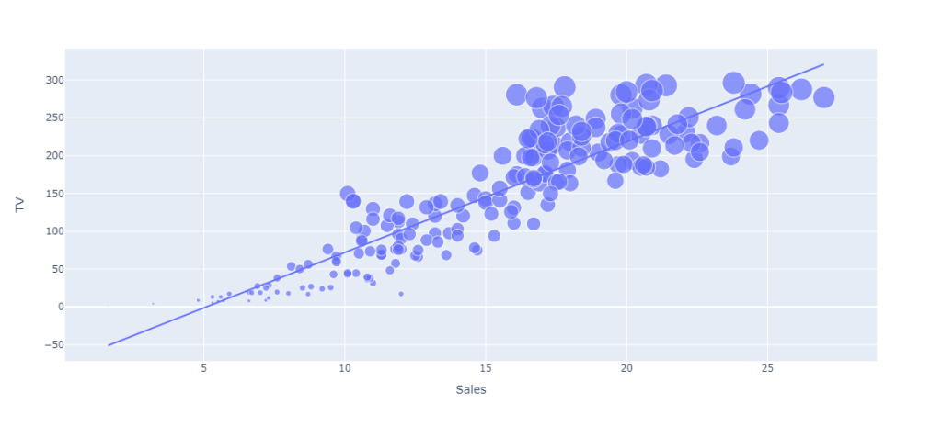

Now let’s visualize the relationship between the amount spent on advertising on newspapers and units sold:

1

figure = px.scatter(data_frame = data, x="Sales",

2

y="Newspaper", size="Newspaper", trendline="ols")

3

figure.show()

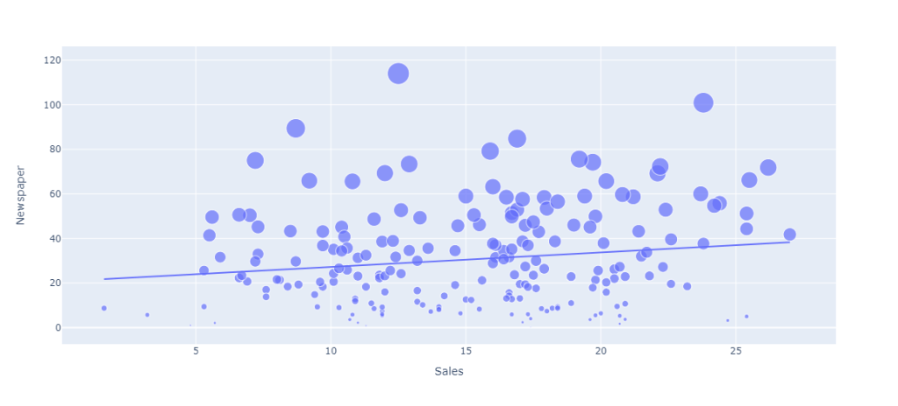

Now let’s visualize the relationship between the amount spent on advertising on radio and units sold:

1

figure = px.scatter(data_frame = data, x="Sales",

2

y="Radio", size="Radio", trendline="ols")

3

figure.show()

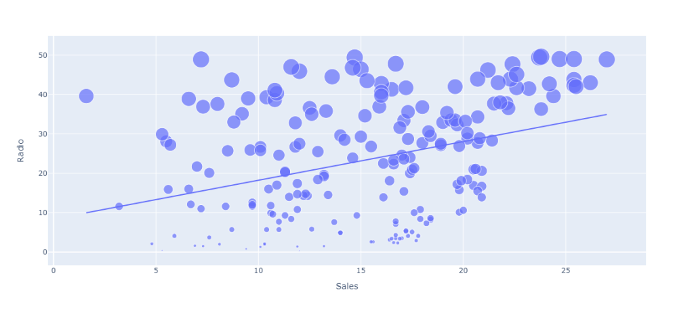

Out of all the amount spent on advertising on various platforms, I can see that the amount spent on advertising the product on TV results in more sales of the product. Now let’s have a look at the correlation of all the columns with the sales column:

1

correlation = data.corr()

2

print(correlation["Sales"].sort_values(ascending=False))

**Sales 1.000000**  
**TV 0.901208**  
**Radio 0.349631**  
**Newspaper 0.157960**  
**Name: Sales, dtype: float64**

## Future Sales Prediction Model

Now in this section, I will train a machine learning model to predict the future sales of a product. But before I train the model, let’s split the data into training and test sets:

1

x = np.array(data.drop(["Sales"], 1))

2

y = np.array(data["Sales"])

3

xtrain, xtest, ytrain, ytest = train_test_split(x, y,

4

test_size=0.2,

5

random_state=42)

Now let’s train the model to predict future sales:

1

model = LinearRegression()

2

model.fit(xtrain, ytrain)

3

print(model.score(xtest, ytest))

Now let’s input values into the model according to the features we have used to train it and predict how many units of the product can be sold based on the amount spent on its advertising on various platforms:

1

#features = [[TV, Radio, Newspaper]]

2

features = np.array([[230.1, 37.8, 69.2]])

3

print(model.predict(features))

**[21.37254028]**

**innovative techniques or approaches for future sales predictions:**

Predicting future sales is a complex and dynamic task, and businesses are continually exploring innovative techniques and approaches to improve the accuracy of their sales forecasts. Here are some innovative methods and strategies for future sales predictions:

**1. Deep Learning and Neural Networks:**

- Deep learning models, such as recurrent neural networks (RNNs) and long short-term memory networks (LSTMs), can capture complex temporal dependencies in time-series data. These models are particularly effective when dealing with sequential sales data and have been used for forecasting in industries like retail and finance.

**2.Predictive Analytics and Advanced Machine Learning:**

- Advanced machine learning algorithms like XGBoost, Random Forests, and Gradient Boosting Machines have gained popularity for their ability to handle large datasets and complex relationships between variables. They are widely used for sales prediction tasks.

**3. Ensemble Methods:**

- Ensemble methods combine the predictions of multiple models to improve accuracy. Techniques like stacking, bagging, and boosting can be applied to sales forecasting to harness the strengths of various algorithms and mitigate their weaknesses.

**4. Time Series Forecasting with Prophet:**

- Facebook's Prophet is an open-source tool specifically designed for time series forecasting. It can handle data with missing values and outliers and incorporates seasonality and holiday effects.

**5. Reinforcement Learning:**

- Reinforcement learning models, such as deep reinforcement learning, can be used to optimize pricing, inventory management, and marketing strategies to maximize sales.

**6. Bayesian Methods:**

- Bayesian models allow for the incorporation of uncertainty into sales predictions. Bayesian neural networks and probabilistic programming can be valuable in quantifying uncertainty in forecasts.

**7. Natural Language Processing (NLP):**

- Utilize NLP techniques to analyze customer reviews, social media sentiment, and textual data related to your products or services. Sentiment analysis can provide insights into customer perceptions that impact future sales.

**8. Customer Segmentation and Personalization:**

- Implement customer segmentation using clustering algorithms. Predict future sales for each segment separately and tailor marketing and product offerings based on customer behavior and preferences.

**9.Anomaly Detection:**

- Incorporate anomaly detection techniques to identify unusual patterns or outliers in your sales data. Detecting anomalies can be valuable for understanding unexpected fluctuations in sales.

**10. Demand Forecasting with IoT and Sensor Data:**

- For certain industries, especially manufacturing and logistics, IoT devices and sensor data can be used to track real-time demand and predict sales more accurately.

1**1. Graph Analytics:**

- Analyze customer networks, supplier relationships, or distribution networks using graph analytics. These insights can help in understanding the impact of network dynamics on sales.

**12. Explainable AI (XAI):**

- As regulatory and ethical concerns grow, there's an increasing need for AI models that can provide transparent explanations for their predictions. XAI techniques are crucial for building trust and understanding the factors that influence future sales predictions.

**13. Dynamic Pricing and Optimization**:

- Implement dynamic pricing algorithms that adjust product or service prices in real time based on factors like demand, competition, and inventory levels. These techniques can optimize revenue and maximize sales.

**14. Blockchain and Smart Contracts:**

- In supply chain and B2B sales, blockchain technology can be used to track transactions, validate authenticity, and enforce smart contracts, ensuring transparency and security in sales data.

**15. Causal Inference**

- Explore causal inference methods to understand the cause-and-effect relationships between variables. Identifying causal factors can lead to more accurate sales predictions.

**16. Augmented Analytics:**

- Leveraging artificial intelligence and machine learning within analytics tools can help business users, even those without data science expertise, make more accurate sales predictions.

**17. Augmented Reality (AR) and Virtual Reality (VR):**

- In some industries like fashion and real estate, AR and VR technologies can be used to provide immersive customer experiences, which can impact sales predictions and customer behavior.

Incorporating these innovative techniques and approaches into your sales prediction process can help your business stay competitive, adapt to changing market conditions, and make data-driven decisions to maximize revenue and growth. The choice of technique should be based on your specific industry, data, and business objectives.

**Reporting and conclusion:**

Example:

Present your sales predictions and insights to company stakeholders in a report or presentation, including visualizations and summaries of the evaluation metrics.

You can use data visualization tools like Matplotlib, Seaborn, or Tableau to create graphs and charts for your data analysis and reports. The specifics of your analysis will depend on your dataset, business goals, and the tools you are using.

Predicting the future sales of a product helps a business manage the manufacturing and advertising cost of the product. I hope you liked this article on future sales prediction with machine learning. Feel free to ask valuable questions in the comments section below.